- 应用场景说明
CA的审批流程启动之后，每一个环节（审批人）完成审批之后，那么当前审批人的名字和当前审批时间将被记录在工程图（类型为drawing）的属性上。
- 部署说明
- 部署JPO
  - 将JPO文件上传到Linux服务器上
  - 使用MQL语句进行部署
Eg:
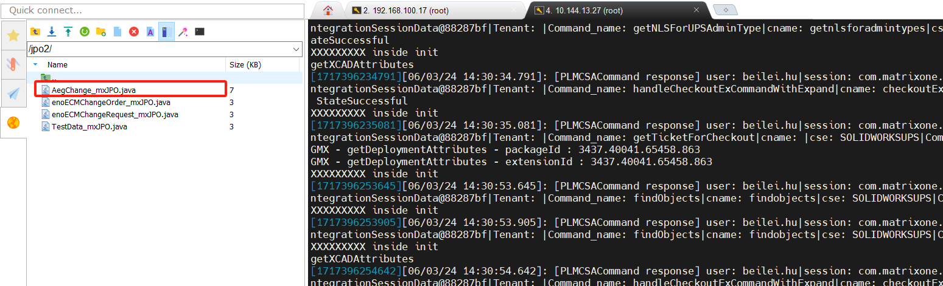
Set context user creator;
insert program "/jpo2/AegChange_mxJPO.java";
compile program AegChange force update;
- 部署触发器
可以将modify.mql文件里mql语句直接复制到MQL Server执行。
add bus "eService Trigger Program Parameters" "AEGGetPersonInfo" "getPersonInfo"
description "modify Action"
policy "Business Rule"
"eService Program Argument 1" "${OBJECTID}"
"eService Program Argument 2" "${ATTRVALUE}"
vault "eService Administration"
"eService Program Name" "AegChange"
"eService Sequence Number" 1
"eService Method Name" "getPersonInfo"
current Active;
modify policy 'Inbox Task' state 'Review' add Trigger Promote Action emxTriggerManager input 'PolicyInboxTaskStateReviewPromoteAction AEGGetPersonInfo';
